**Experiment 6**

Valiveti Manikanta Bhuvanesh

19BCD7088

AIM: Write a program to perform weather forecasting using R using svm

**Code:**

data<-read.csv("weather.csv")

summary(data)

head(data)

apply(apply(data,2,is.na),2,sum)

data<-na.omit(data)

data$RainTomorrow[data$RainTomorrow =='Yes']<-1

data$RainTomorrow[data$RainTomorrow =='No']<-0

data$RainTomorrow<-factor(data$RainTomorrow, levels = c(0, 1))

set.seed(123)

data<-data[c(3,4,24)]

data[-3]=scale(data[-3])

data2=sample.split(data$RainTomorrow,SplitRatio=0.80)

traindata<-subset(data,data2==TRUE)

testdata<-subset(data,data2==FALSE)

**SVM with Linear kernel**

model1<-svm(formula=RainTomorrow ~ .,data = traindata,type="C-classification",kernel="linear")

summary(model1)

pred1<-predict(model1,newdata=testdata[-3])

pred1

tab1<-table(testdata[,3],pred1)

tab1

plot(model1,traindata)

**OUTPUT:**

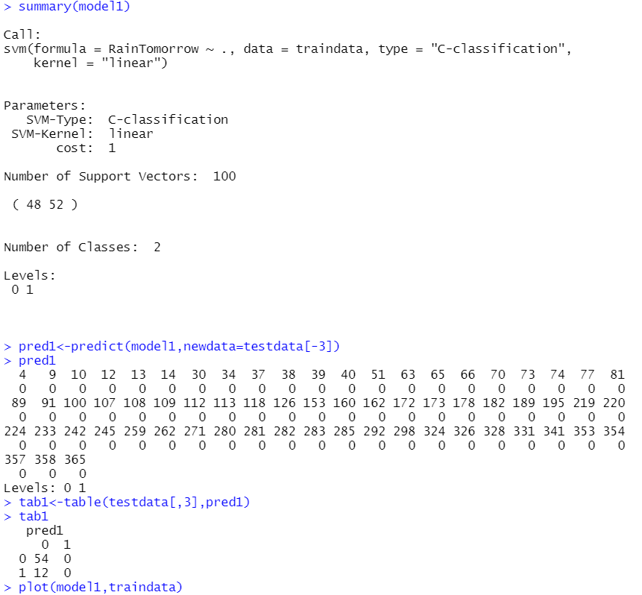

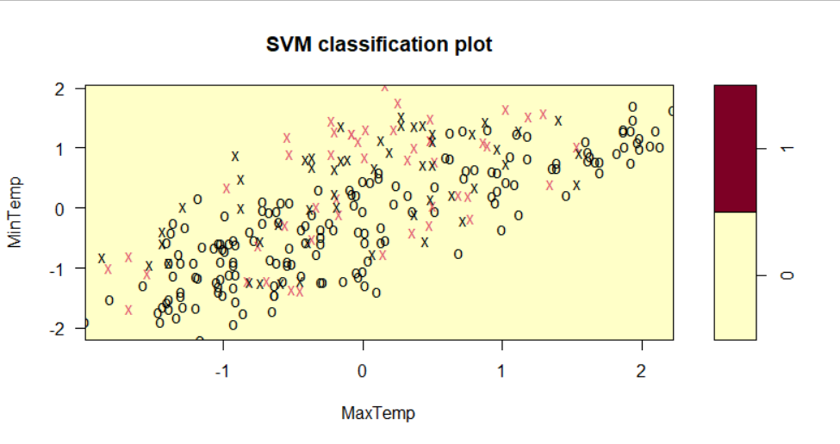

**SVM WITH RADIAL KERNAL**

model2<-svm(formula=RainTomorrow~.,data = traindata,type="C-classification",kernel="radial")

summary(model2)

pred2<-predict(model2,newdata=testdata[-3])

pred2

tab2<-table(testdata[,3],pred2)

tab2

plot(model2,traindata)

**OUTPUT:**

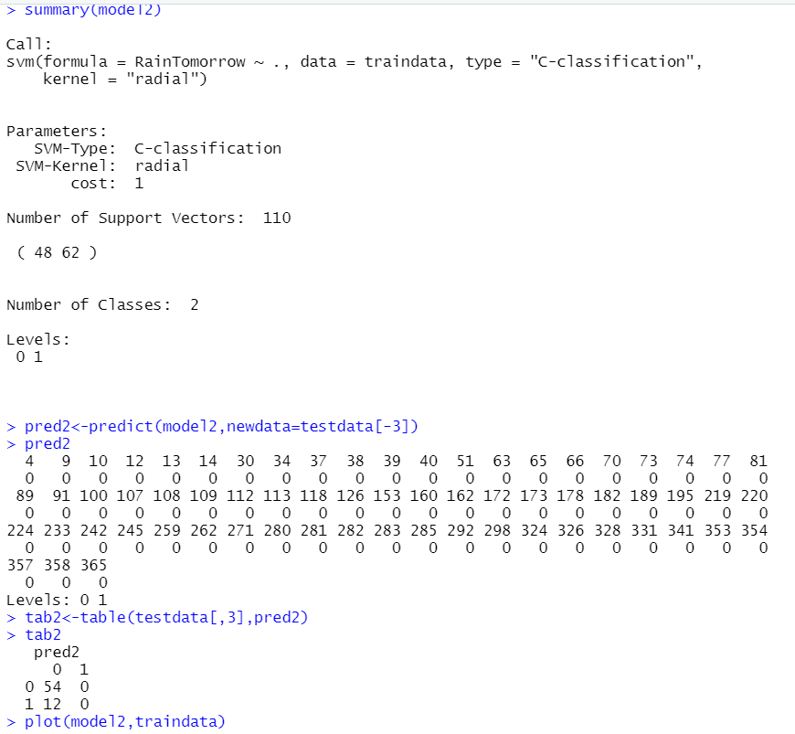

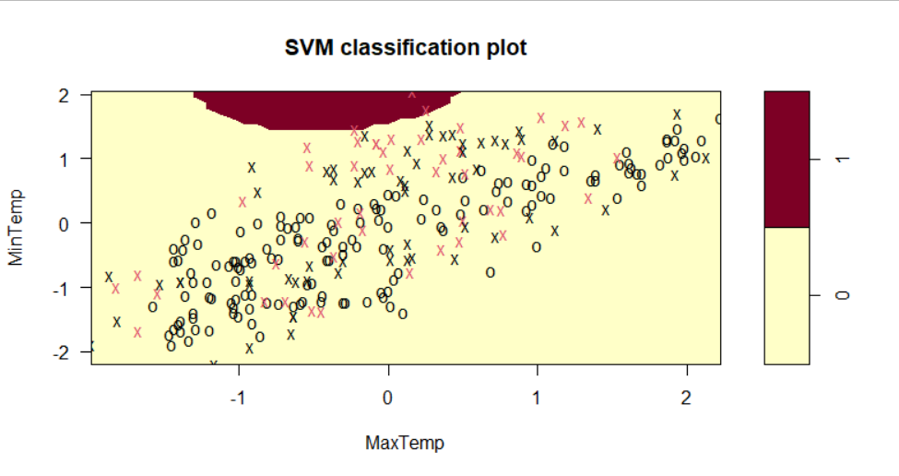

**SVM WITH POLYNOMIAL KERNAL**

model3<-svm(formula=RainTomorrow~.,data = traindata,type="C-classification",kernel="polynomial")

summary(model3)

pred3<-predict(model3,newdata=testdata[-3])

pred3

tab3<-table(testdata[,3],pred3)

tab3

plot(model3,traindata)

**OUTPUT:**

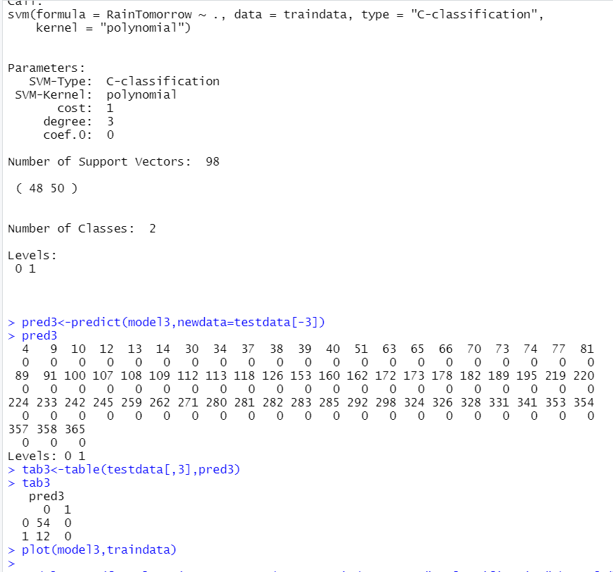

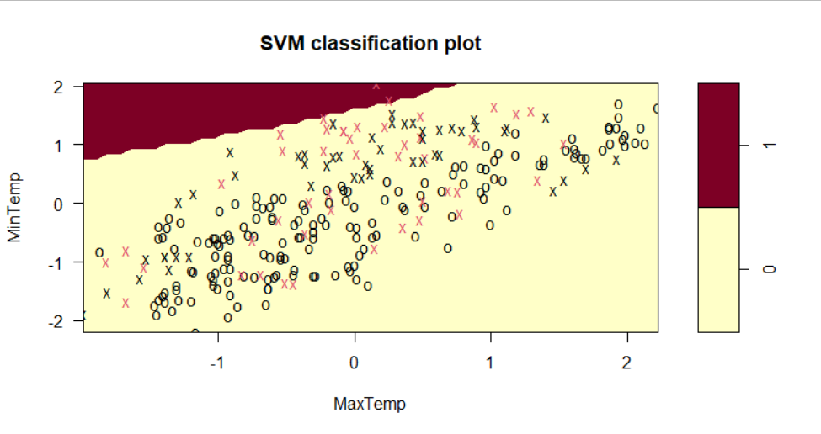

**SVM WITH SIGMOID KERNAL**

model4<-svm(formula=RainTomorrow~.,data = traindata,type="C-classification",kernel="sigmoid")

summary(model4)

pred4<-predict(model4,newdata=testdata[-3])

pred4

tab4<-table(testdata[,3],pred4)

plot(model4,traindata)

**OUTPUT:**



